The electronic clock thermostat Comfort Touch, with a fine LCD display, comes with a floor temperature sensor and energy consumption management system.  Comfort Touch thermostat has pre-programmed functions adjusted to Lithuanian climate and weekly mode. Factory settings and data are retrieved beyond power failure.  The thermostat is wall-mounted into a standard recessed box. The energy consumption management system informs of the percentage consumption of adjusted temperature levels, what your monthly consumption is, and the upcoming year’s expenditure. | 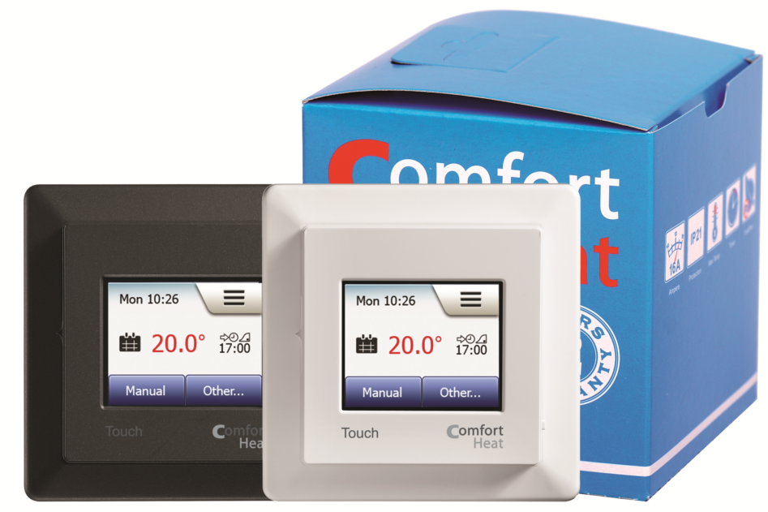

TECHNICAL DATA
Voltage | 100-230 V AC 50/60 Hz
Max load | 16 A / 3600 W
Screen | 2”, 176x220 points, touchscreen
ON / OFF switch | Built-in interrupter 2-pole
Standby mode energy consumption | < 0,5 W
Temperature range | +5°C ... +40°C
Hysteresis | 0,4°C
Energy consumption and saved time memory | 5 year
Saved programming | Unlimited time
Sensor type | Floor (NTC) and room
Sensor resistance | 14,8 kOhm / 20°C
Dimensions | 84x84x40 mm
Protection class | IP21
Warranty | 3 year

PRODUCT LIST
Type | Temperature range | Sensor | Model | Stock code
Comfort Touch White | +5°C ... +40°C | Floor and room, 3m | Elko | 19115967
Comfort Touch Black | +5°C ... +40°C | Floor and room, 3m | Elko | 19115968

WIRING DIAGRAM
