Comfort ECO electronic thermostat with floor sensor is suitable for flush mounting in a standard recessed box. The thermostat provides optimal comfort avoiding cold tiles during spring and autumn or as protection against damaging wooden floors.  Comfort ECO thermostat has a built-in timer for automatic night setback and the possibility to activate night setback or frost protection via external input.  With a temperature setting range of 0-40°C, a night setback, frost protection and limited temperatures thermostat ensures comfort and protects the property from excessive temperatures. Comfort ECO thermostat comes with present heating schedules suitable for most homes. | 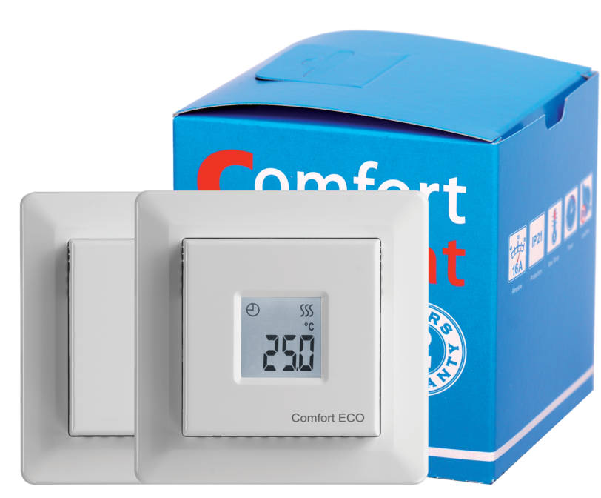

TECHNICAL DATA
Voltage | 230V AC 50/60 Hz
Max load | 16 A / 3600 W
Control pollution degree | 2
ON / OFF switch | Built-in interrupter 2-pole
Pre-programmed in factory | I-V, VI-VII mode
Design of control | PWM/PI
Output relay | Make contact - SPST - NO
Display | Segment
Stand by power | <0,5 W
Temperature range | +0°C … +40°C
Sensor type | Floor (NTC) and room
Sensor resistance | 14,8 kOhm / 20°C
Dimensions | 84x84x20 mm
Protection class | IP21
Warranty | 3 year

PRODUCT LIST
Type | Temperature range | Sensor | Model | Stock code
Comfort ECO White | +0°C … +40°C | Floor and room, 3m | Elko | 19115948
Comfort ECO Black | +0°C … +40°C | Floor and room, 3m | Elko | 19115949

WIRING DIAGRAM
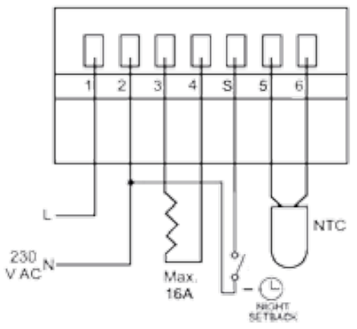 | • Sleek design  • User-friendly / intuitive menu  • Easy installation  • Energy-efficient  • Offset adjustment

