The C501 electronic thermostat features a floor temperature sensor and is designed for wall mounting in a standard recessed box. It includes a 3-meter floor temperature sensor cable for convenient installation. | 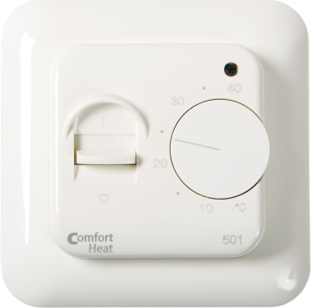

TECHNICAL DATA
Voltage | 230V AC 50/60 Hz
Max load | 14 A / 3200 W
ON / OFF switch | Built-in interrupter 1-pole
Temperature range | +5°C ... +40°C
Hysteresis | +/-0,4°C
Setting of the temperature range | Min / max
Sensor type | Floor (NTC)
Sensor resistance | 14,8 kOhm / 20°C
Temperature setback | fixed 5°C
Light indicator | LED
Dimensions | 80x80x50 mm
Protection class | IP21
Warranty | 3 year

PRODUCT LIST
Type | Temperature range | Sensor | Model | Stock code
C 501 | +5°C ... +40°C | Floor, 3 m | Jussi | 19115952

WIRING DIAGRAM
